# Testing:

1.Unit Testing:

UNIT TESTING is a level of software **testing** where individual units/ components of a software are tested. The purpose is to validate that each **unit** of the software performs as designed. A **unit** is the smallest testable part of any software. It usually has one or a few inputs and usually a single output.

# 2. Black Box Testing:

# Black Box Testing, also known as Behavioral Testing, is a software testing method in which the internal structure/design/implementation of the item being tested is not known to the tester. These tests can be functional or non-functional, though usually functional.

Advantages of using black box testing are:

* Efficient when used on large systems.
* Testing helps to identify contradictions in functional specifications.
* No need for the tester to have detailed functional knowledge of system.
* Tests will be done from an end user's point of view, because the end user should accept the system. (This testing technique is sometimes also called Acceptance testing.)
* Test cases can be done as soon as the functional specifications are complete.
* Since the tester and developer are independent of each other, testing is balanced and unprejudiced.
* Tester may be non-technical.

List of Black Box Testing ae:

# Test Name: Login Test

## **Pre-condition**: User must get log into the system

|  |  |  |  |  |  |
| --- | --- | --- | --- | --- | --- |
| **Test no** | **Test**  **Scenario** | **Test Input Data** | **Expected result** | **Actual result** | **Result**  **(Pass/Fail)** |
| 1 | To check if the user logs in or not | Email:  aa@gmail.com Password:123 | User should log in | User logs in | pass |

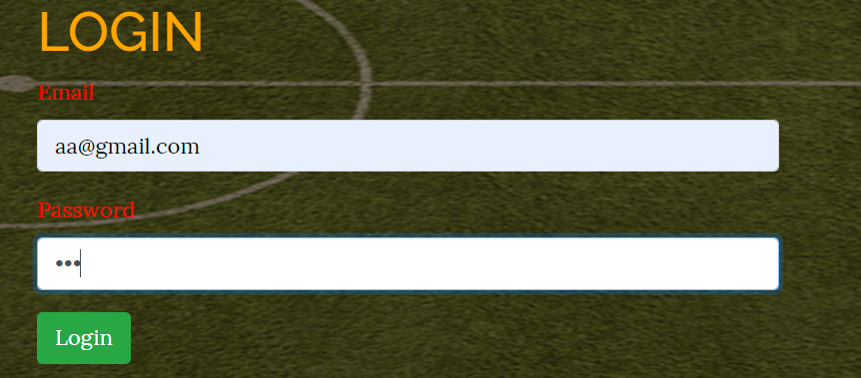

# Test Name: creating account Test

## **Pre-condition**: account must get create

|  |  |  |  |  |  |
| --- | --- | --- | --- | --- | --- |
| **Test no** | **Test**  **Scenario** | **Test Input Data** | **Expected result** | **Actual result** | **Result**  **(Pass/Fail)** |
| 2 | To check if the account is created | Name: Zen  Address: Ktm  Email:  zen@gmail.com Password:111 | Account should be created | Account created | pass |

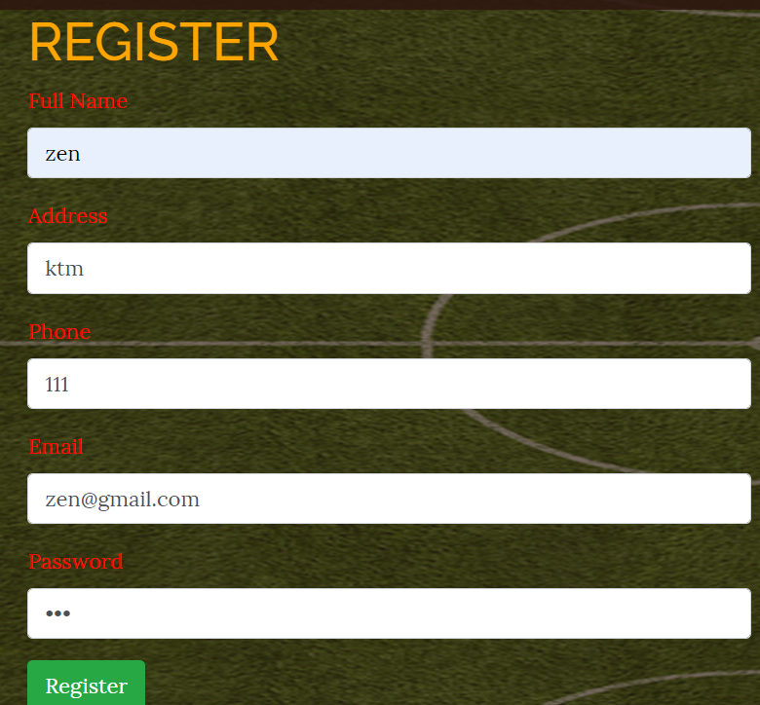





# Test Name: booking Test

## **Pre-condition**: booking must be done

|  |  |  |  |  |  |
| --- | --- | --- | --- | --- | --- |
| **Test no** | **Test**  **Scenario** | **Test Input Data** | **Expected result** | **Actual result** | **Result**  **(Pass/Fail)** |
| 3 | To check if booking is done | Name: Zen  Address: Ktm Phone: 111  Date: 2019-07-05  Time: 10:00 | Booking should be done | Booking done | pass |

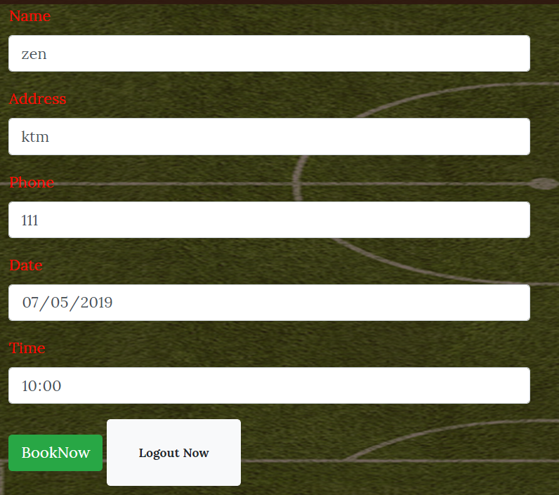





# Test Name: booking Test for same time

## **Pre-condition**: booking must not be done because of the same time

|  |  |  |  |  |  |
| --- | --- | --- | --- | --- | --- |
| **Test no** | **Test**  **Scenario** | **Test Input Data** | **Expected result** | **Actual result** | **Result**  **(Pass/Fail)** |
| 4 | To check if booking is done | Name: Zen  Address: Ktm Phone: 111  Date: 2019-07-05  Time: 10:00 | Booking should not be done | Booking not done | pass |



# Test Name: creating account Test

## **Pre-condition**: account must not be created because account already exists

|  |  |  |  |  |  |
| --- | --- | --- | --- | --- | --- |
| **Test no** | **Test**  **Scenario** | **Test Input Data** | **Expected result** | **Actual result** | **Result**  **(Pass/Fail)** |
| 5 | To check if the account is created | Name: Zen  Address: Ktm  Email:  zen@gmail.com Password:123  Phone:111 | Account should not be created | Account not created | pass |



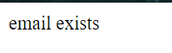

# Test Name: string validity Test

## **Pre-condition**: account must not be created because phone no is string

|  |  |  |  |  |  |
| --- | --- | --- | --- | --- | --- |
| **Test no** | **Test**  **Scenario** | **Test Input Data** | **Expected result** | **Actual result** | **Result**  **(Pass/Fail)** |
| 6 | To check if the account is created | Name: Zen  Address: Ktm  Email:  zen@gmail.com Password:123  Phone: abd | Account should not be created | Account not created | pass |

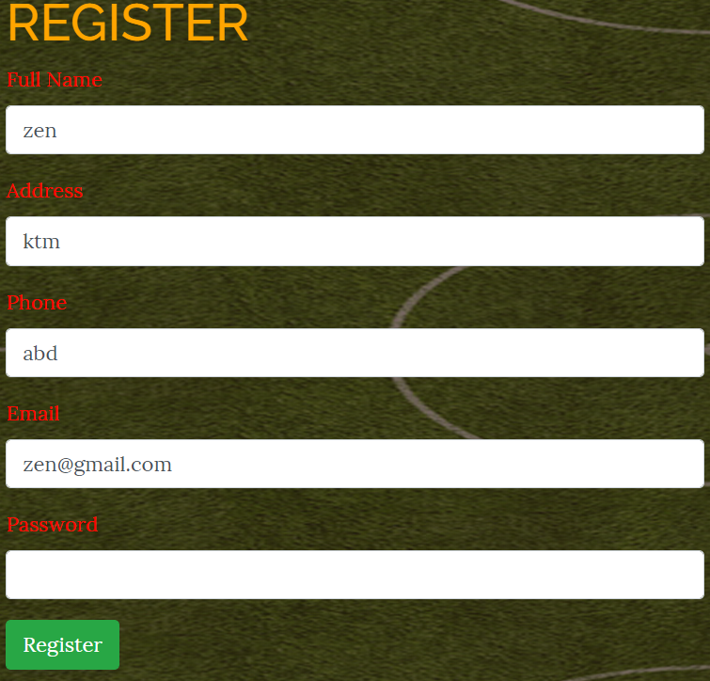

# Test Name: password availibility Test

## **Pre-condition**: account must not be created because password is not set

|  |  |  |  |  |  |
| --- | --- | --- | --- | --- | --- |
| **Test no** | **Test**  **Scenario** | **Test Input Data** | **Expected result** | **Actual result** | **Result**  **(Pass/Fail)** |
| 7 | To check if the account is created | Name: Zeni  Address: Ktm  Email:  zem@gmail.com Password:  Phone:111 | Account should not be created | Account not created | pass |

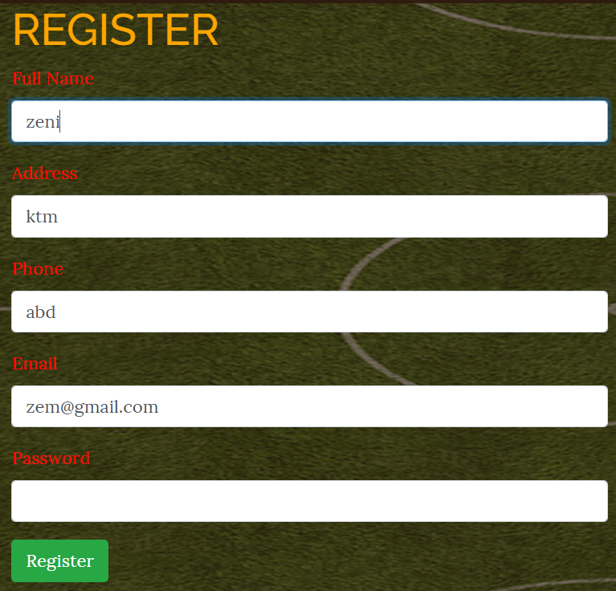

# Test Name: email availability Test

## **Pre-condition**: account must not be created because email is not set

|  |  |  |  |  |  |
| --- | --- | --- | --- | --- | --- |
| **Test no** | **Test**  **Scenario** | **Test Input Data** | **Expected result** | **Actual result** | **Result**  **(Pass/Fail)** |
| 8 | To check if the account is created | Name: Zeni  Address: Ktm  Email:  Password: 123  Phone:123 | Account should not be created | Account not created | pass |

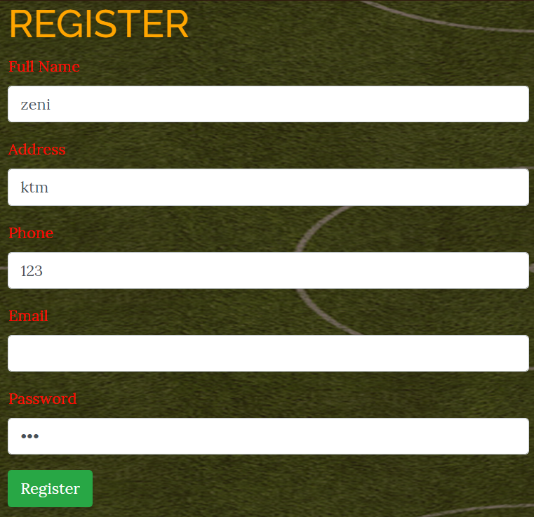

# Test Name: password Test

## **Pre-condition**: login is not done because wrong password

|  |  |  |  |  |  |
| --- | --- | --- | --- | --- | --- |
| **Test no** | **Test**  **Scenario** | **Test Input Data** | **Expected result** | **Actual result** | **Result**  **(Pass/Fail)** |
| 9 | To check if the account logs in | Email: zen@gmail.com  Password: 135 | Login is not done | Not logged in | pass |

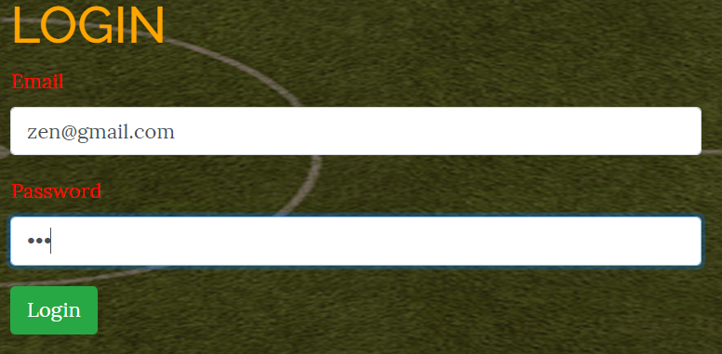

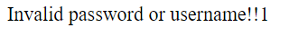

# Test Name: login email Test

## **Pre-condition**: login is not done because wrong email

|  |  |  |  |  |  |
| --- | --- | --- | --- | --- | --- |
| **Test no** | **Test**  **Scenario** | **Test Input Data** | **Expected result** | **Actual result** | **Result**  **(Pass/Fail)** |
| 10 | To check if the account logs in | Email: ze@gmail.com  Password: 123 | Login is not done | Not logged in | pass |

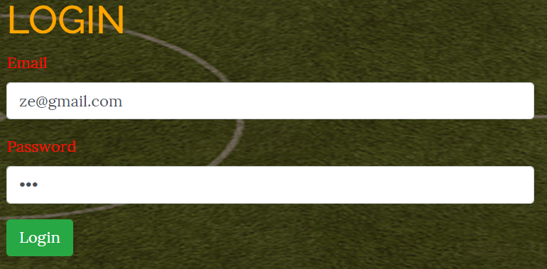

# Test Name: booking date validation Test

## **Pre-condition**: booking must not be done because date is not set

|  |  |  |  |  |  |
| --- | --- | --- | --- | --- | --- |
| **Test no** | **Test**  **Scenario** | **Test Input Data** | **Expected result** | **Actual result** | **Result**  **(Pass/Fail)** |
| 3 | To check if booking is done | Name: Zen  Address: Ktm Phone: 123  Date:  Time: 10:00 | Booking should not be done | Booking not done | pass |

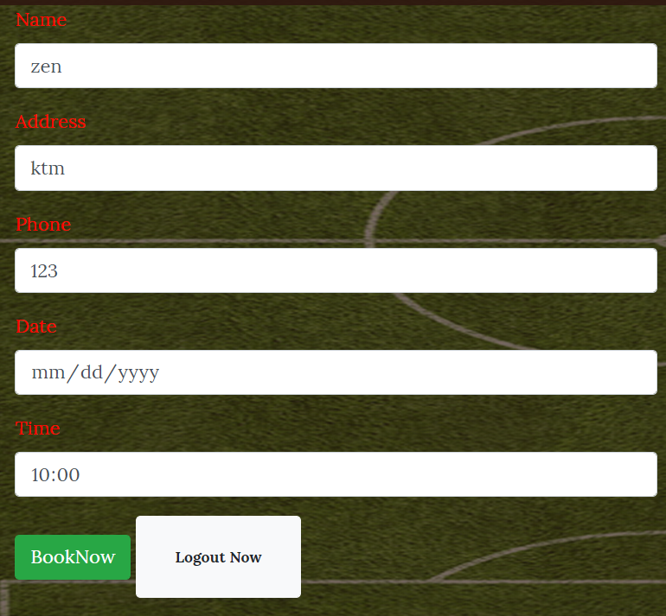

# Test Name: booking time validationTest

## **Pre-condition**: booking must not be done because time is not set

|  |  |  |  |  |  |
| --- | --- | --- | --- | --- | --- |
| **Test no** | **Test**  **Scenario** | **Test Input Data** | **Expected result** | **Actual result** | **Result**  **(Pass/Fail)** |
| 3 | To check if booking is done | Name: Zen  Address: Ktm Phone: 123  Date: 2019-07-12  Time : | Booking should not be done | Booking not done | pass |

